Sri Lanka Institute of Information

Technology



Lab Submission

Lab sheet 08

**IT24104301**

**Karannagoda K. V. R.**

**Probability and Statistics | IT2120**

B.Sc. (Hons) in Information Technology

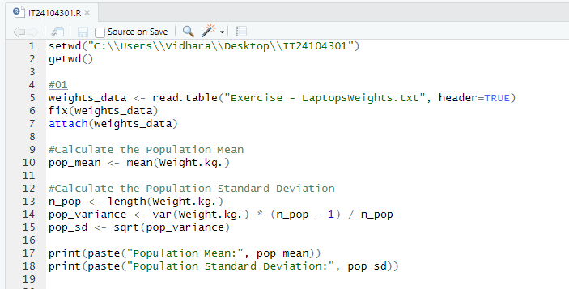

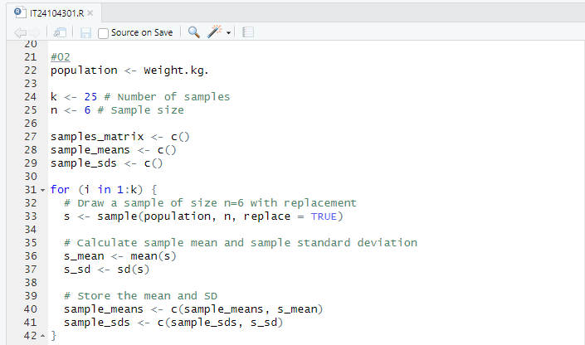

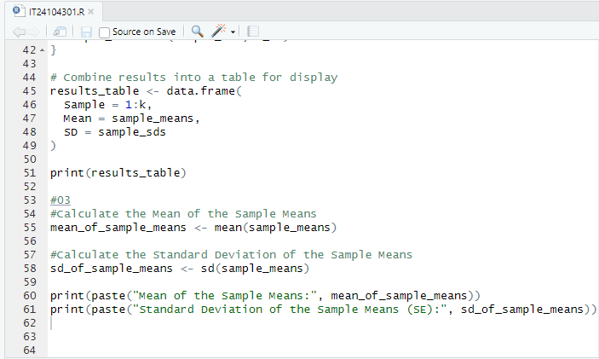

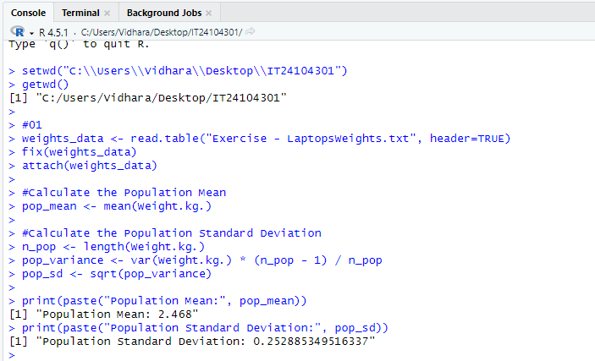

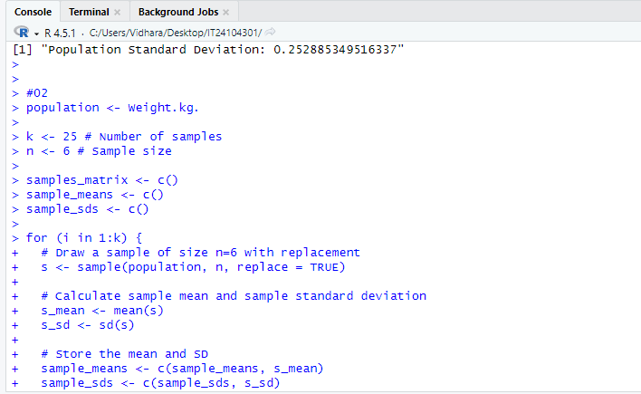

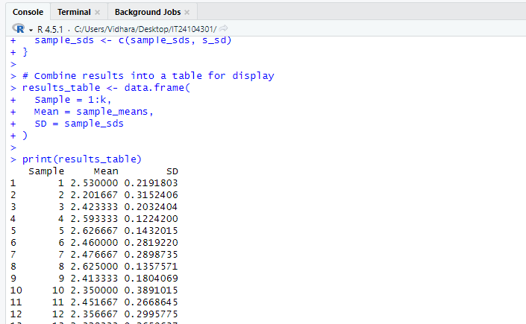

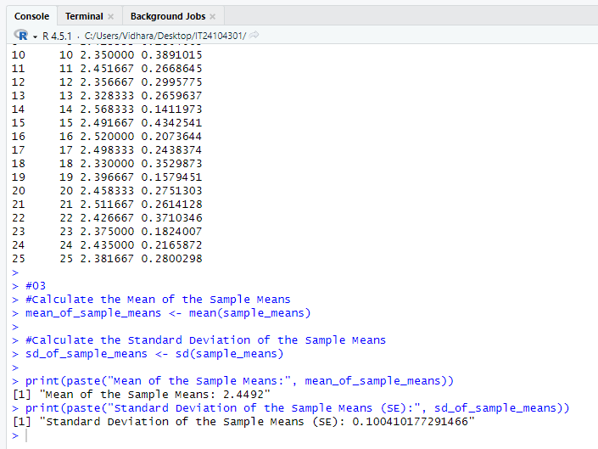

Relationship :-

(based on the Central Limit Theorem)

Mean of sample means ≈ Population means

SD of sample means < Population SD